**`**

**Prospectus**

**PROSPECTUS**

**PROSPECTUS**





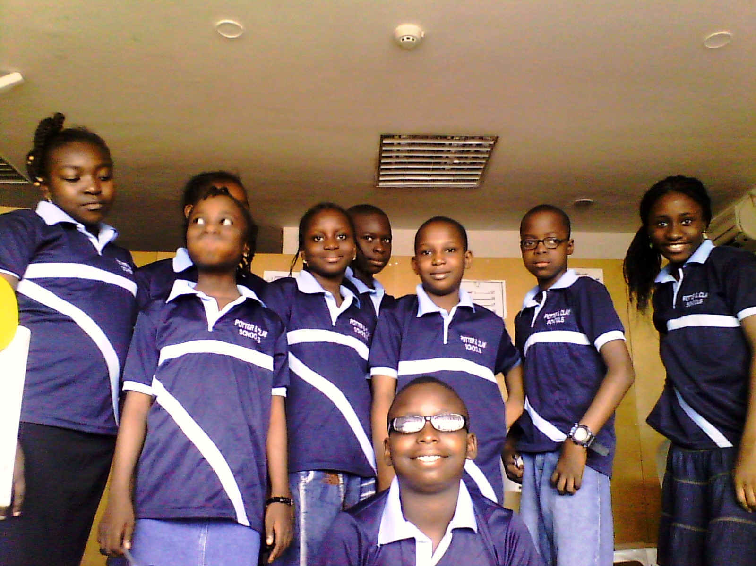

**Founded September, 2013**

“*Moulding your future, securing your destiny”*

**PROSPECTUS**

**POTTER & CLAY**

**Potter &Clay**

**Founded September, 2013**

“*Moulding your future, securing your destiny”*

***TABLE Of Contents***

* A bout the school
* School anthem
* Aims & Objectives
* Code of conduct
* The board of Governors
* Admissions
* Fees

**Curriculum**

* Junior secondary
* Senior secondary
* Continuous Assessment
* Facilities
* Uniform

**Development Program @ Potter & Clay School.**

* Leadership skills
* Social Skills
* ICT development

**Co – Curricular activities**

* Clubs
* Sports facilities
* Religion

**Boarding routine.**

* Glasses
* Hair
* Phone
* Health & medicine
* Parent-Teacher-Association.

**Potter & Clay School** is a coeducational secondary school founded on September 2013 to educate young girls and boys from all parts of the world with a strong emphasis on holistic education of the students encompassing academic, social and spiritual well being while striving to achieve an international character.

The school is about 2km from the Ilesa – Akure expressway via Gold FM, Iloko-Ijesa road, Ilesa.

The school motto is **“*moulding your future, securing your destiny”***and strives for excellence in all facets of life. We aim to bring out and nurture the best of potential in our students.

**School Anthem:**

**🙥** Potter and clay secondary school we are **🙥** striving for the best in all we do **🙥** We are a school with honour and pride **🙥** Potter and clay school **🙥** Moulding our future, securing our destiny **🙥** Building future leaders.

**Aims and Objectives:**

* To prepare our students for the dynamics of a continuously demanding world
* To give them self belief and confidence.
* To enhance them with life skills to dominate their environment.
* Develop their minds and capacities for responsibilities and align them with a strong faith in God to overcome life challenges.
* To nurture their analytical skills and imbue them with a positive outlook to life and a value system of merit and hard work.

🌍 [www.potter-clay.com.ng](http://www.potter-clay.com.ng) 🖂 potter.clay.schools@gmail.com

**Code of Conduct:**

The school expects a reasonably high level of behaviour from the students and a sense of responsibility on their part.

**Regulation:**

1. **Good behaviour**: Understand that you are in a community of students and exhibit good conduct at all times to fellow students, teachers, parents and visitors.
2. **Fight** : fighting of any sort is not allowed and will attract expulsion.
3. Bullying: Bullying or intimidation of any sort is not permitted and will be severely sanctioned.
4. **Appearance** : students are to be clean and smart at all times in their cloths, shoes, hair, and general appearance.
5. **Communication** : The language of communication shall be English in the school at all times.
6. **Fellowship**: Students are to respond to calls to fellowship gathering and places of worship at all times required.

**Board of Governors:**

The principal is responsible to the governing board of the schools and the board is responsible for certain oversight functions upon the school.

The Principal reports formally o school activities to the board each time.

**Admission:**

Admission to the school is through an examination which holds at different periods of the year before resumption.

🌍 [www.potter-clay.com.ng](http://www.potter-clay.com.ng) 🖂 potter.clay.schools@gmail.com

**Fees:**

As a privately owned school, fees are reviewed in line with the current operating realities of our economy.

**New intakes only:**

* Registration fee
* Medical charges
* Stationeries and books
* Uniform and house wear
* Extra curriculum charges

Fees are payable to the school on or before resumption.

**Curriculum:**

The school runs the national Junior Secondary and Senior Secondary Programs.

**Junior Secondary:**

In the first three years the school emphasizes the fundamental skills in the core subjects which are English language, Mathematics, Basic Science, Civics, Basic Technology, Social Studies, and Vocational Studies in addition to the full range of subjects.

After the first three years prescribed, examinations are taken.

**Senior Secondary School:**

In the fourth, fifth and sixth years, students are prepared for the senior secondary school certificate examination, SSCE and the GCE on six core subjects and additional ones.

🌍 [www.potter-clay.com.ng](http://www.potter-clay.com.ng) 🖂 potter.clay.schools@gmail.com

**Continuous Assessment:**

This is based on class work both written and oral practical projects and regular test and home work.

**Facilities**: well-constructed class rooms and staff room with laboratory and utility blocks.

**Uniform**: Uniform as approved by the school is to be worn in all classes.

**Development Program**: Several programs are designed to enhance the student experience in the school.

**Co – Curriculum Activities**: Several academic clubs and literary societies are available for students to participate.

**Sports Facilities**: Facilities are available to allow students experience areas of sports interest.

**Religion**: The Christian faith is the mode of worship for the school and all students are mandated to gather for prescribed assemblies in this mode of worship.

**Glasses**: All students are to have their eyes tested before entering the school. Acceptable lenses for spectacles are clear and not tinted or photo chromic, two pairs are needed.

**Hair**: Boys are to keep the hair well-trimmed and not bushy. Girls are expected to plait their hair with a clean and neat look all the time. Hair fixes are not allowed.

**Phone**: Phones are not allowed in the school.

**Health and Medicine**All students must be immunized against tetanus, yellow fever, typhoid and hepatitis; a medical certificate will be required.

**Parents Teacher Associations**: the school encourages vibrant PTA with prescribed times of meeting during the term and approved dues to be paid.

🌍 [www.potter-clay.com.ng](http://www.potter-clay.com.ng) 🖂 potter.clay.schools@gmail.com